Exercise 1
Write a JavaScript program using ES6 features to calculate the total and average marks of a student. The program should declare variables using let and const, use an arrow function to compute the average, and display the result using template literals. The program should print the student name, total marks, and average marks in a formatted message.

Sample Code Structure

let studentName = "Arun";
let mark1 = 85;
let mark2 = 90;
let mark3 = 88;
const calculateAverage = (m1, m2, m3) => {
return (m1 + m2 + m3) / 3;
}
let average = calculateAverage(mark1, mark2, mark3);
console.log(`Student Name: ${studentName}`);
console.log(`Average Marks: ${average}`);

Expected Output
Student Name: Arun
Average Marks: 87.66

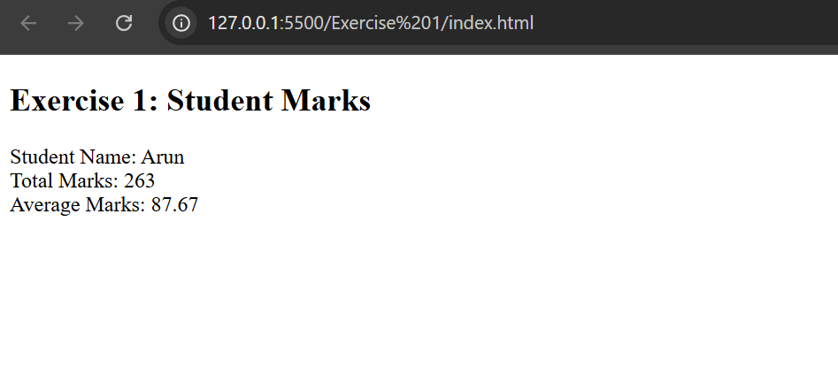
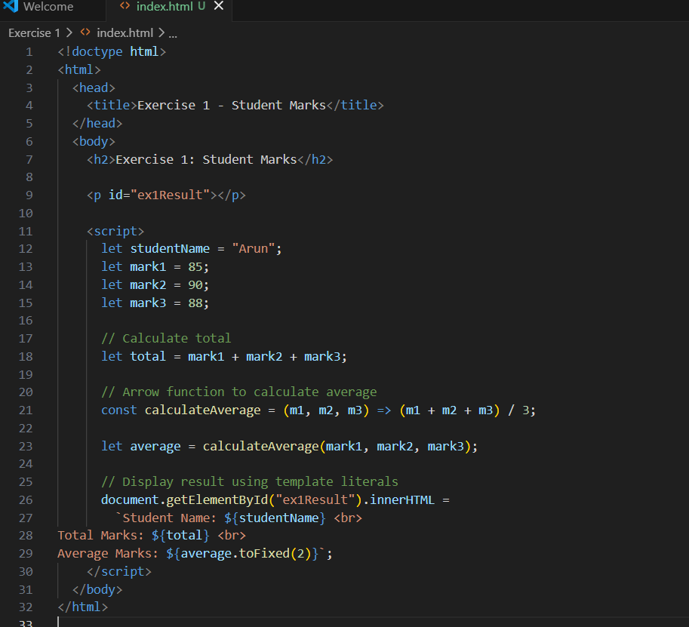

Exercise 2
Create a JavaScript program that defines an object representing a student with properties such as id, name, department, and marks. Use object destructuring to extract the values and display them. Then create a new object using the spread operator that adds an additional property called grade based on the marks and display the updated object.

Sample Code Structure
const student = {
id: 101,
name: "Priya",
department: "CSE",
marks: 92
};

const {id, name, department, marks} = student;
console.log(id, name, department, marks);
const updatedStudent = {
...student,
grade: "A"
};
console.log(updatedStudent);

Expected Output
101 Priya CSE 92
{ id: 101, name: 'Priya', department: 'CSE', marks: 92, grade: 'A' }

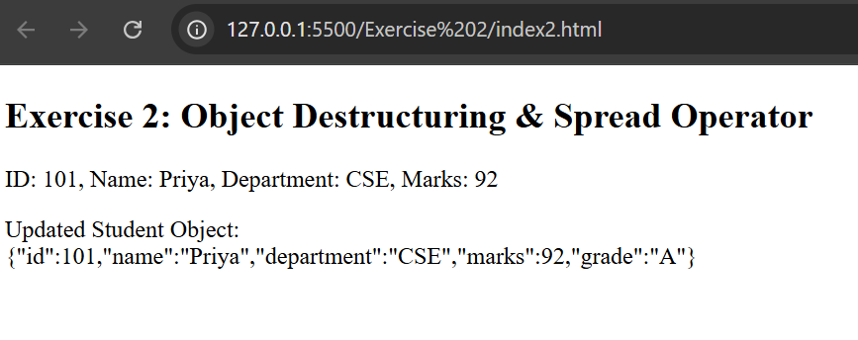
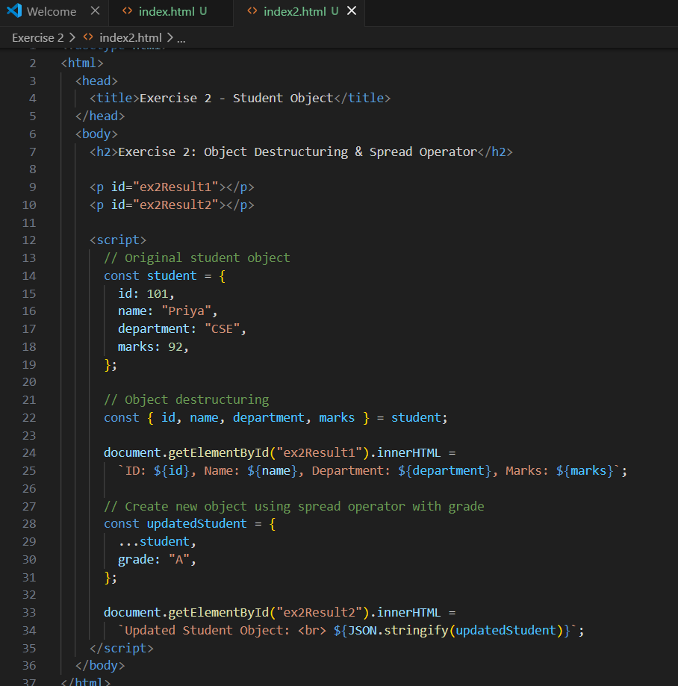
Exercise 3
Develop a JavaScript program using ES6 classes and promises to simulate a simple course enrollment system. Create a class named Course with a constructor to initialize the course name and instructor. Include a method to display course details. Implement a promise that checks whether seats are available and prints either “Enrollment Successful” or “Course Full” based on the condition.

Sample Code Structure
class Course {
constructor(courseName, instructor) {
this.courseName = courseName;
this.instructor = instructor;
}
displayCourse() {
console.log(`Course: ${this.courseName}, Instructor: ${this.instructor}`);
}
}
let course1 = new Course("Web Technologies", "Dr. Kumar");
course1.displayCourse();
let enrollCourse = new Promise((resolve, reject) => {
let seatsAvailable = true;
if(seatsAvailable)
resolve("Enrollment Successful");
else
reject("Course Full");
});
enrollCourse
.then(msg => console.log(msg))
.catch(err => console.log(err));

Expected Output
Course: Web Technologies, Instructor: Dr. Kumar
Enrollment Successful

